 | BLINKIT  Sales data  python project  Bheemaray

Overview of Blinkit Sales Data
The dataset records various products sold across multiple retail outlets, capturing features such as item type, fat content, outlet size, and sales figures. Each entry represents an item at a specific outlet with associated metrics like sales and product ratings. The data covers a variety of product categories and outlet types, making it useful for analyzing sales performance and retail trends

Objective of Project
The major aim of this project is to gain insight into the sales data of Blinkit to understand the different factors that affect sales of the different Item Type and Item Fat Content

Data wrangling
- Importing library
- import pandas as pd
- import numpy as np
- import matplotlib.pyplot as plt
- import seaborn as sns

- Reading Files
df=pd.read_csv("blinkit_data.csv")
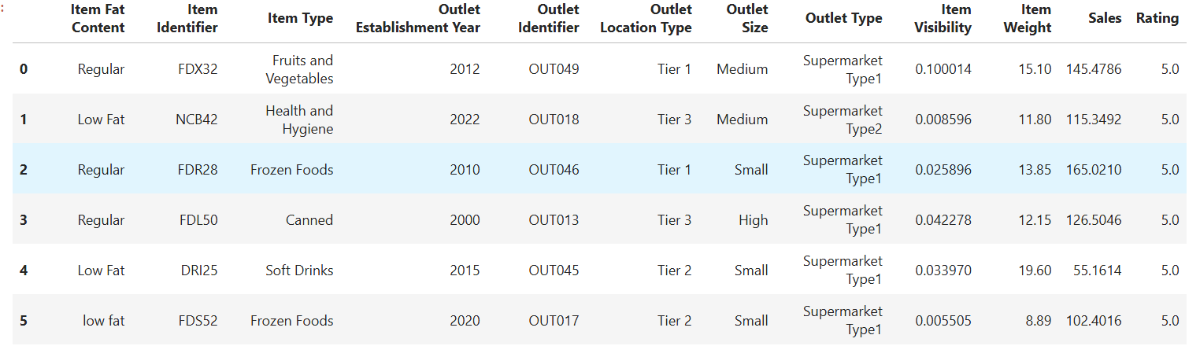
df.head(5)

- Filed Information
df.columns
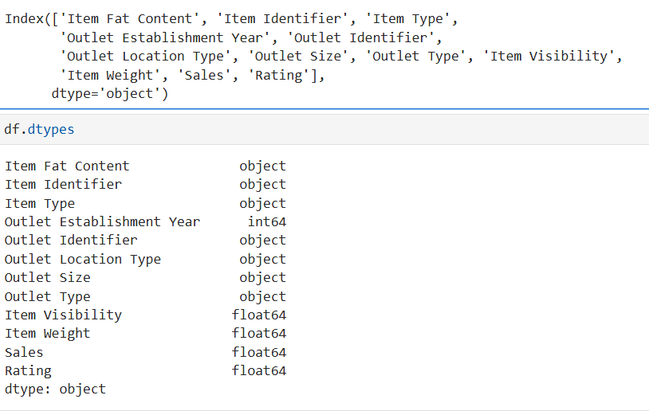

- How to clean Data and Replace values
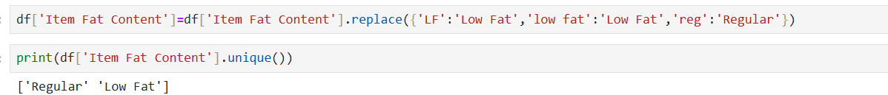

- Business KPIS Requirement
In this step, we calculate the KPIs for the Business of Blinkit (sum, average, count, min, Max). This is help for Analysis and find out values in numbers or percentages
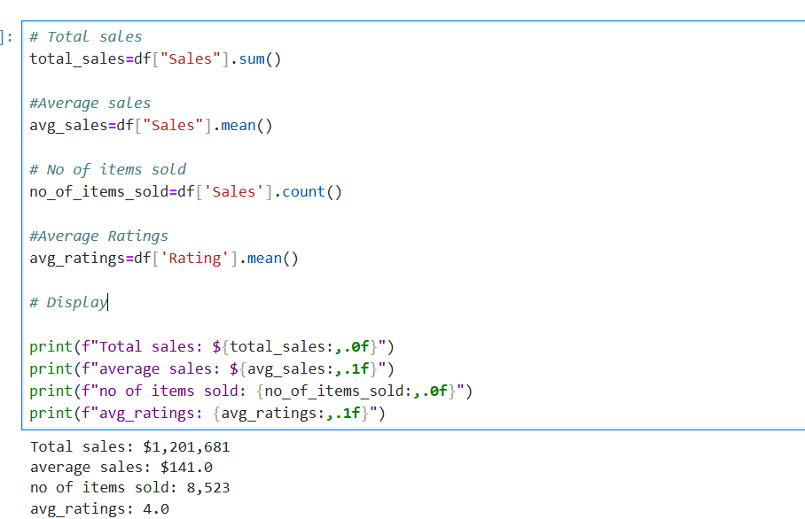
6.Answering Business Question
- Total by item type:
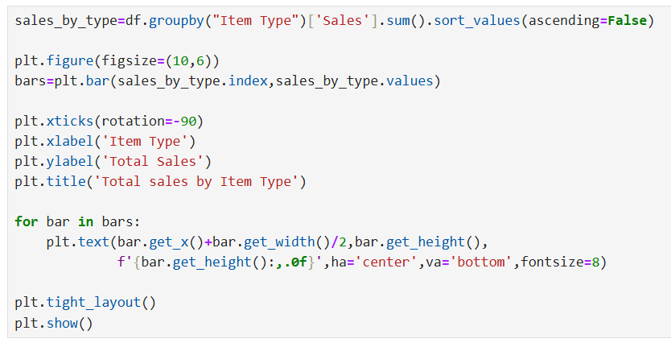

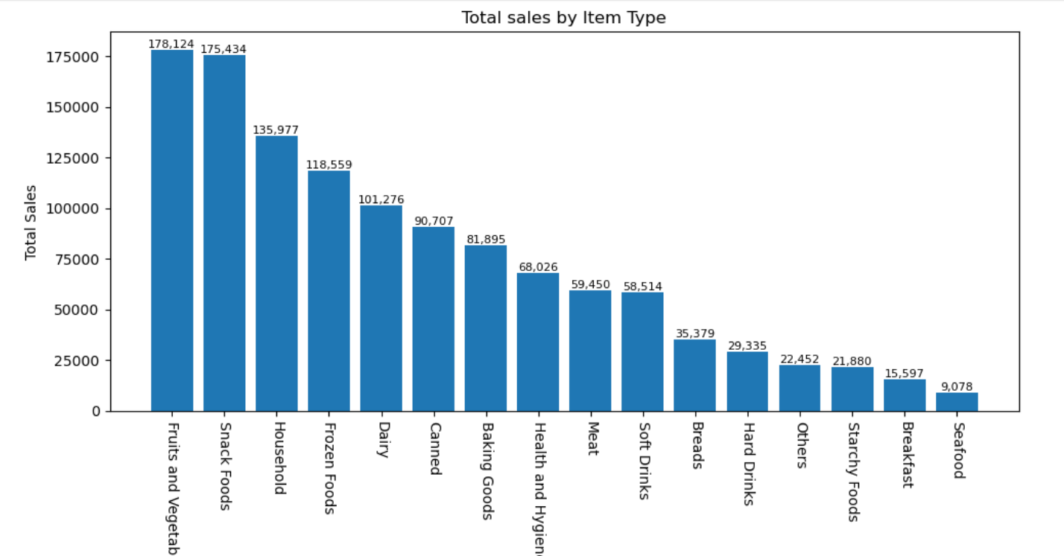
2. Total Sales by Fat Content:
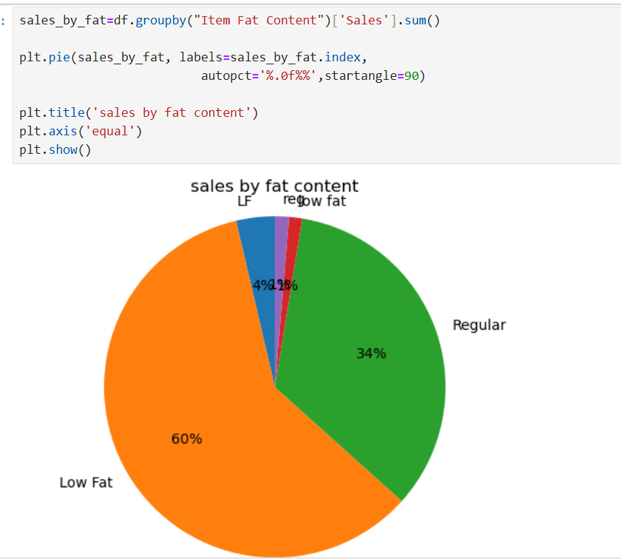

2)Sales by outlet Size
